Ryan Farruggia

CSC 35

Professor Ghansah

23 April 2021

Lab Report #8

Output displaying results of **incorrect** key input with only three asterisks as specified:

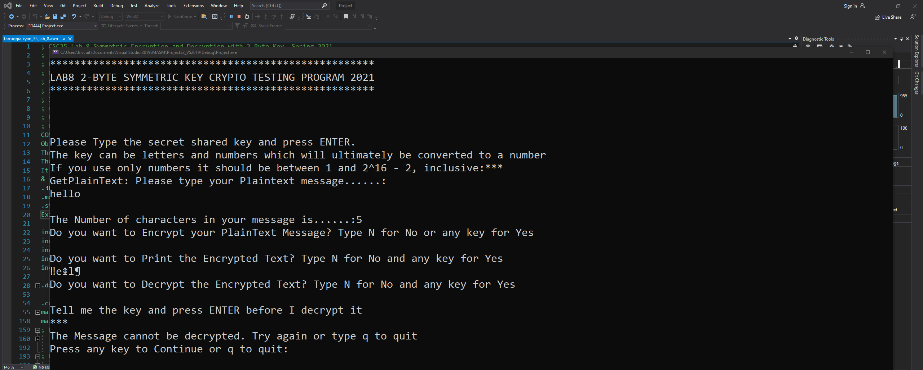

Output displaying results after **correct** key input:

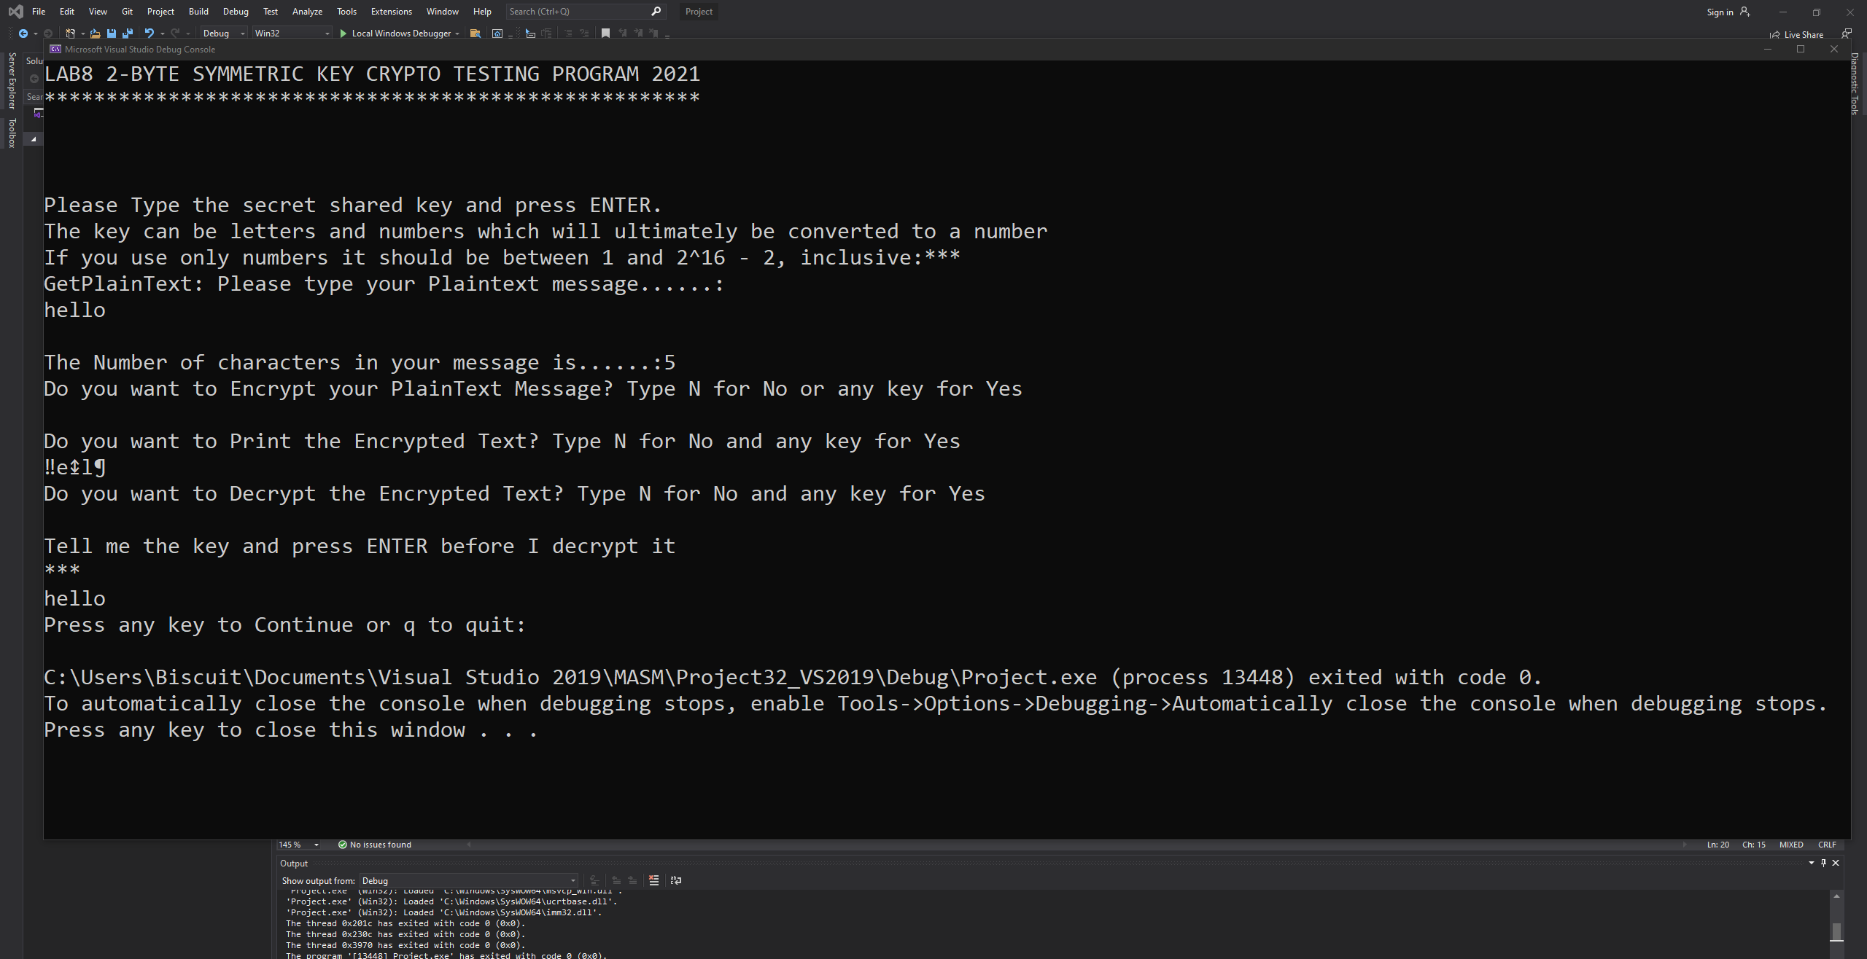

**Lessons Learned:**

I learned about basic symmetric key encryption and its utility in assembly language and beyond. The encryption method can be used to both encrypt and decrypt messages without a middleman and is an efficient way of providing a basic level of security to certain information.

**Problems Encountered:**

I faced several issues with the encryption procedure, as it was nearly impossible to get it to function without the use of BYTE and WORD pointers and I misplaced them several times. I also could not get the program to output the correctly decrypted message but I was missing a single line of code that fixed the issue.

**Length of Assignment:**

It took me about 6 hours total to complete this assignment. This was by far the most difficult assignment thus far and I ran into significantly more problems than I originally expected.

**Suggestions:**

Simplify the program. Perhaps instead of combining encryption and decryption into one lab, split it into two separate labs so there is not as much of a disconnect with the material.